
Company
Logotype

Cone Beam Computed Tomography- Report



Porur Dental X-rays & CBCT

Patient Name : Miss. Solomiya Mary | Date of Report : 17.04.2024
Age/ Gender : 25 years/ Female | Region of Interest : CBCT Maxilla
Referring doctor: Thooth- C | Indication : Impacted tooth
Clinical Notes: Nil
PATIENT INFORMATION

CBCT Maxilla provided
CBCT – IMAGE DETAILS

RADIOGRAPHIC INTERPRETATION

- Deciduous teeth: 53, 63;
- The tooth 13 appears to be obliquely placed within the alveolar bone, distally tipped and lies above the periapical aspect of the deciduous tooth: 53 and 12 and its root in proximity to the medial wall of right maxillary sinus.
- The tooth 23 appears to be obliquely placed within the alveolar bone, distally tipped and lies above the periapical aspect of the deciduous tooth: 63 and 22 and its root in proximity to the medial wall of left maxillary sinus.
- Both the impacted teeth 13, 23 lie palatal to the deciduous teeth 53 and 63 respectively and appear to cause discontinuity of the palatal bone.
- The crown of the impacted 13 and 23 are in contact with the root portion of 12 and 22 respectively.
- Distance between the crown of 13 and the alveolar ridge: 4.34 mm
- Distance between the crown of 23 and the alveolar ridge : 5.39 mm
- The left maxillary sinus is present with mucosal thickening in relation to its floor.

RADIOGRAPHIC IMPRESSION


- Impacted teeth: 13, 23
- Retained deciduous teeth: 53, 63
- Left maxillary sinusitis.

IMAGES FOR REFERENCE

RECONSTRUCTED PANORAMA VIEW
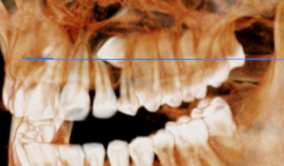
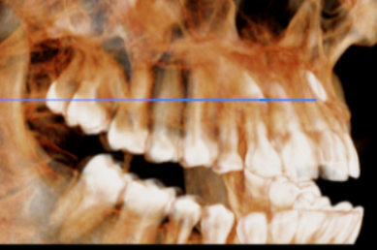
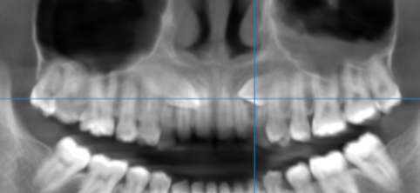
3-DIMENSIONAL VIEW
CROSS- SECTIONAL IMAGES
13 REGION | 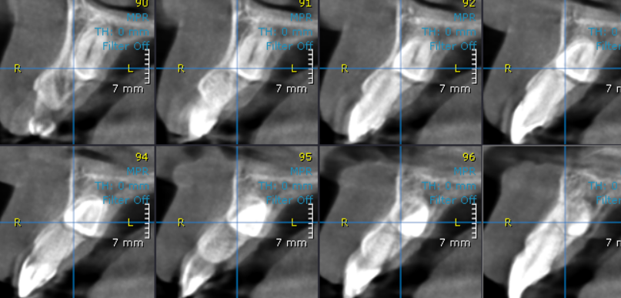
23 region | 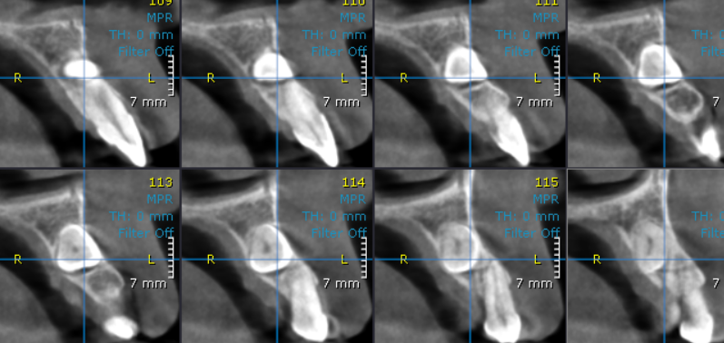

**** End of report ****

